Right on Target
Introduction
It is important that when you work out you don’t over or under exercise. To reap the most health benefits from exercise, your exercise intensity must generally be at a moderate or vigorous level. For weight loss, the more intense your exercise, or the longer you exercise, the more calories you burn.
So think about your reasons for exercising. Do you want to improve your fitness, lose weight, train for a competition or do a combination of these? Your answer will help determine the appropriate level of exercise intensity. Be realistic and don't push yourself too hard, too fast. Fitness is a lifetime project, not a sprint. Of course, if you have any medical conditions or you're not sure what your exercise intensity should be, talk to your doctor.
Understanding exercise intensity
When you're doing aerobic activity, such as walking or biking, exercise intensity correlates with how hard the activity feels to you. Exercise intensity also is reflected in your breathing and heart rate, whether you're sweating, and how tired your muscles feel.
There are two basic ways to measure exercise intensity:
- How you feel
Exercise intensity is a subjective measure of how hard physical activity feels to you while you're doing it — your perceived exertion. Your perceived level of exertion may be different from what someone else feels doing the same exercise. For example, what feels to you like a hard run can feel like an easy workout to someone who's more fit.
- Your heart rate
Your heart rate offers a more objective look at exercise intensity. In general, the higher your heart rate during physical activity, the higher the exercise intensity. Studies show that your perceived exertion correlates well with your heart rate. So if you think you're working hard, your heart rate is likely elevated. You can use either way of gauging exercise intensity. If you like technology and care about the numbers, a heart rate monitor might be a useful device for you.
Target Heart Rate
You need to know your Maximum Heart Rate and your correct training zone to know if you are training at the right pace.
You can easily find your Target Heart Rate (THR) with this simple method. Subtract your age from 220 (226 for women) to calculate your Maximum Heart Rate (MHR). Find your training zone below and multiply that number times your maximum rate.
TRAINING ZONES
Healthy Heart Zone (Warm up) 50 - 60% of maximum heart rate: The easiest zone and probably the best zone for people just starting a fitness program. It can also be used as a warm up for more serious walkers. This zone has been shown to help decrease body fat, blood pressure and cholesterol. It also decreases the risk of degenerative diseases and has a low risk of injury. 85% of calories burned in this zone are fats!
Fitness Zone (Fat Burning) 60 - 70% of maximum heart rate: This zone provides the same benefits as the healthy heart zone, but is more intense and burns more total calories. The percent of fat calories is still 85%.
Aerobic Zone (Endurance Training) 70 - 80% of maximum heart rate: The aerobic zone will improve your cardiovascular and respiratory system AND increase the size and strength of your heart. This is the preferred zone if you are training for an endurance event. More calories are burned with 50% from fat.
Anaerobic Zone (Performance Training) 80 - 90% of maximum heart rate: Benefits of this zone include an improved cardiorespiratory system, and a higher lactate tolerance ability which means your endurance will improve and you'll be able to fight fatigue better. This is a high intensity zone burning more calories, 15% from fat.
Measurements to be taken
In this investigation, students will record heart rate before and after exercise using an ear clip sensor. This sensor measures how our ear lobe (or finger) changes its light transparency as blood flows through it.
Materials needed
- Mini with heart rate clip
- Data Collection Sheet (master attached)
Mini Set Up
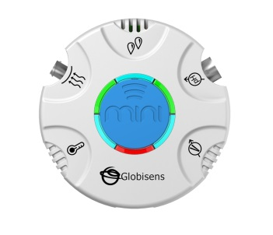For this experiment you will setup the Mini from the GlobiLab software menu. Use the directions in Getting to Know the Mini if you need assistance.
- Sensor Selection - select Ambient Temperature
- Sampling Rate - 100/second
- Number of Samples - select 3000
When you hit the Run button, the green LED lights will circle, indicating that the Mini is in Manual data collection mode. Keep in mind that the Heart Rate sensor will take about two seconds to establish the heart rate.
Experiment Set Up
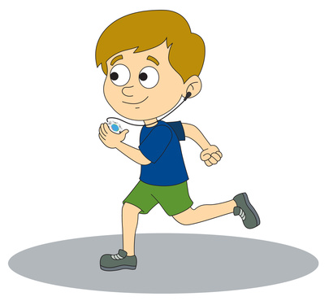
Connect the ear clip to the input located directly under the External Temperature icon. Make sure that the ear clip is well positioned on your finger or ear lobe as shown.

Experiment Procedure
- Attach the Heart Rate clip and sit quietly for one minute. Then begin the data collection by clicking the Run icon on the GlobiLab software.
- Using the markers, select a 30 second section from the middle of the collection and count the number of heart beats. This will be the Resting Heart Rate (RHR). Record this number on the data collection sheet and save your graph. Your graph will look something like this:
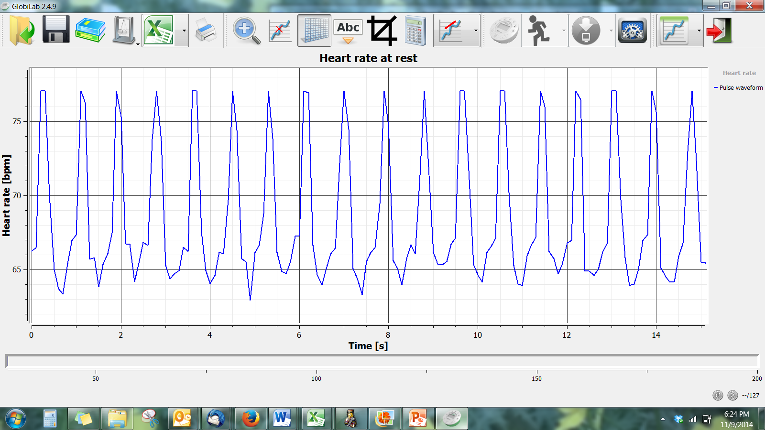
- Using the Resting Heart Rate, have each student calculate Maximum Heart Rate (MHR). Read with students the different Training Zones and determine in which zone the students want to be working. Then calculate the Target Heart Rate (THR).
- Attach the Heart Rate clip and have students complete the activities below. Press the Run icon on the GlobiLab software to record the heart rates immediately after completing the activity. Be sure to allow the heart rate to return to the normal resting heart rate before starting the next activity or have students take turns doing the activities.
- Standing (measure for 1 minute while standing)
- After walking slowly for 3 minutes
- After speed walking for 2 minutes
- After jogging in place for 2 minutes
- After doing 30 jumping jacks
- After running in place as fast as possible for 1 minute
- Open the GlobiLab software and connect the Mini to the computer through the wireless Bluetooth.
- Click on the download icon to transfer the data from data collection 4a from the Mini memory to the GlobiLab software.
- Use the magnifying tool to zoom in on the first 35 seconds of your collection and count the beats between the 5 second and 35 second points. Record this number on the data collection sheet and save your graph with the name of the exercise by clicking on the SAVE icon. Repeat for 4b, 4c, 4d, 4e and 4f.
Questions & Observations
- Did anyone reach their maximum heart rate? If so, what activity were they doing?
- What activity produced the greatest heart rate?
- Which activities created heart rates within the Target Heart Rate zone?
- What happened to your heart rate during the recovery time after an activity?
- What physical activities do you think would get your heart beating at the maximum heart rate?
- Could you tell when your heart rate was increasing or decreasing? Describe how you felt when this was happening.
- Why would an athlete have a slower resting heart rate than a non-athlete?
- Why would a slower resting heart rate indicate a healthier heart?

Right on Target

Student Name:
 |  | Beats/Minute
Resting Heart Rate
Maximum Heart Rate | 220 - age
Target Heart Rate | 50% to 85% of Max. Heart Rate (be sure to calculate both ends of the range)
Heart Rate After:
Standing
Walking slowly for 3 minutes
Speed walking for 2 minutes
Jogging in place for 2 minutes
After 35 jumping jacks
Running in place for 1 minute

NGSS Standards
Performance Expectations
Construct an argument that plants and animals have internal and external structures that function to support survival, growth, behavior, and reproduction. 4-LS1-1

Science and Engineering Practices
Construct an argument with evidence, data, and/or a model..

Disciplinary Core Ideas
LS1.A: Structure and Function. Plants and animals have both internal and external structures that serve various functions in growth, survival, behavior, and reproduction.

Crosscutting Concepts
A system can be described in terms of its components and their interactions.

Common Core State Standards Connections
ELA/Literacy
W.4.1 - Write opinion pieces on topics or texts, supporting a point of view with reasons and information.

Florida Next Generation Standards Correlation
- SC.4.N.A - Scientific inquiry is a multifaceted activity; the processes of science include the formulation of scientifically investigable questions, construction of investigations into those questions, the collection of appropriate data, the evaluation of the meaning of those data, and the communication of this evaluation.
- SC.4.N.1.2 - Compare the observations made by different groups using the same tools and seek reasons to explain the differences across groups.
- SC.4.N.1.4 - Attempt reasonable answers to scientific questions and cite evidence in support.
- SC.4.N.1.5 - Compare the methods and results of investigations done by other classmates.
- SC.4.N.1.6 - Keep records that describe observations made, carefully distinguishing actual observations from ideas and inferences about the observations.
- SC.4.N.1.7 - Recognize and explain that scientists base their explanations on evidence.
- SC.4.N.1.8 - Recognize that science involves creativity in designing experiments.

Language Arts
- LAFS.4.SL.1.1 - Participate in collaborative conversations with diverse partners about grade 1 topics and texts with peers and adults in small and larger groups.
- LAFS.4.RI.1.3 - Describe the connection between a series of historical events scientific ideas or concepts or steps on technical procedures in a text.

Mathematics
- MACC.4.MP.5 - Use appropriate tools strategically
- MACC.4.MP.8 - Look for and express regularity in repeated reasoning.

Physical Education
- PE.4.C.2.3 - Use technology to gather information about performance.
- PE.4.L.4.3 - Maintain heart rate within the target heart rate zone for a specified length of time during an aerobic activity.

